DEMO 4
Soumya Sen Gupta: 2012EEY7535
Siddharth Srivastava: 2012EEY7506
- Implement a scheme to de-blur the images: Demo4_a.jpg and Demo4_b.jpg
Steps followed
- Find blur angle and blur length
  - Performing Median Filter before restoring the blurred image
  - Converting image from spatial domain to frequency domain
  - Performing Log Transform
  - Converting to cepstral domain
  - Finding edges in image
  - Calling hough transform
  - Iterating 10 times to find 10 highest angle values
  - For each angle value
    - Rotate the image
    - Taking average of all the columns
    - If Zero Crossing found then return it as the blur length
    - If Zero Crossing not found then find the lowest peak calculate the blur length using Lowest Peak
- For every blur angle and corresponding blur length calculate the point spread function
- Deconvolve image I using Lucy- Richardson algorithm
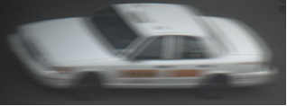  Figure 1: Original Image (Demo4_a.jpg) | 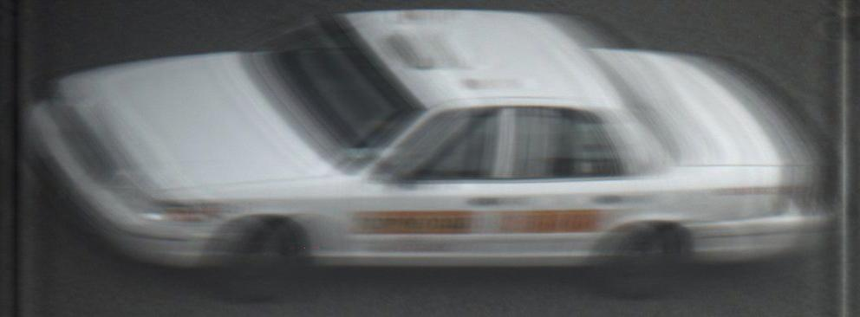  Figure 2: Deblurred Image
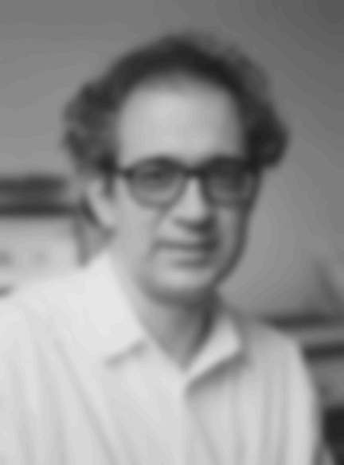  Figure 3: Original Image | 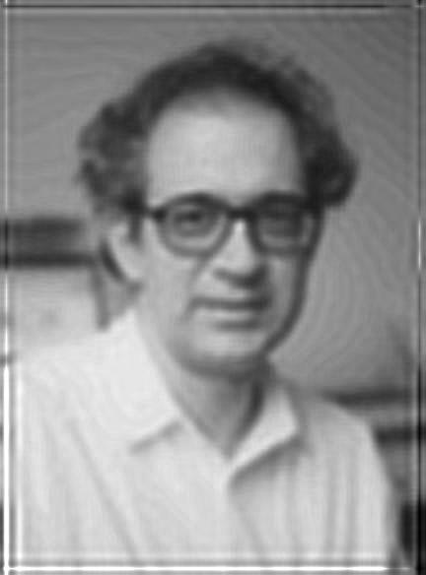  Figure 4: Deblurred Image

- Implement a scheme to de-noise the image: Demo4_c.jpg

Steps followed

- Pass the image through a median filter to remove the noise

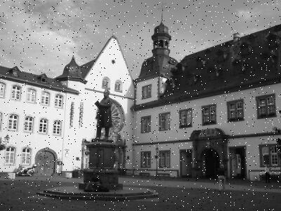
Figure 5: Original Image (Demo4_c.jpg)

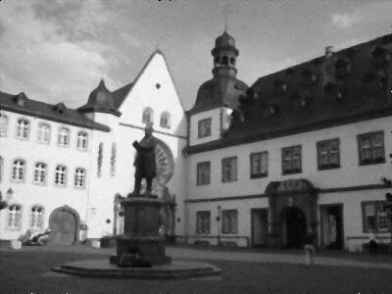
Figure 6: Image after removing noise
- Implement a scheme to retain only the metallic structure and the people in the image

Steps followed

- Convert the image from RGB to HSV
- Find the correct HSV values to get the metallic structure
- Find the people in the image based on Histogram of Object Gradient features

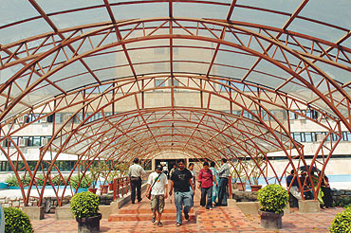
Figure 7: Original Image

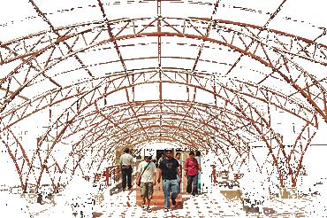
Figure 8: Frames and People

